REVIEW WORKSHEET / 2nd Grade
Name __________________________________________ Grade __________________
Teacher: Carlos Pérez Aguirre
Queridos alumnos y alumnas: Esta guía está basada en los objetivos de aprendizaje de la primera unidad de Inglés de primero medio. De esta manera podrás practicar algunas de las habilidades más importantes de esta unidad y conocer cuáles son tus aprendizajes.
Para desarrollarla puedes usar un diccionario tradicional u on-line. Evita usar un traductor pues no tiene sentido engañarte a ti mismo. Saludos cordiales.
Objetivos de aprendizaje:
OA9 Demostrar comprensión de ideas generales e información explícita en textos adaptados y auténticos simples.
OA10 Demostrar comprensión de textos no literarios al identificar: -Propósito o finalidad del texto. -Idea principal, etc.
OA15 Escribir para explicar, expresar opiniones y narrar, usando: -Variedad de palabras, oraciones y estructuras aprendida.

I Read this text and answer
Some professions are common, and some are not. Some people choose their jobs on their own and some because it is a family tradition.

This is the case of Luis Torres. The same as his grandfather, Luis occupied himself repairing the shoes of the people in his town. The town’s soccer team were his main clients.

“When I was a kid, I spent all the time looking at my grandfather. And when somebody told him I was bothering, he always answered: He’s not bothering, he’s just learning”. But inheritance went further. After his death, he adopted his grandfather’s job and he is also a bonesetter.

Lots of patients from all over the country come to get their legs, arms, hands and ribs touched by his fingers to get them back in place. “What doctors do is put casts; and when there’s a broken bone, there’s no other way, but for sprains and dislocations, sometimes even doctors send me their patients”.

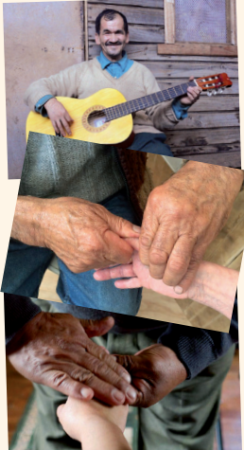

To preserve popular traditions is another of his main motivations. He is also a good payador (folk rhymer) and can improvise verses. “I’m a composer of payas (verses) and a bonesetter”, he says proudly.

1. How did Luis Torres occupy himself?
a) He played in a soccer team. b) He repaired shoes. c) He was a grandfather.

2. According to the first paragraph, what can we say about professions?
a) They are different b) They are very similar. c) They are traditional.

3. What did Luis Torres use to do when he was a kid?
a) He bothered at his grandfather b) He didn’t work c) He looked at his grandfather.

4. According to the fourth paragraph, what can we say about his patients?

a) All their patients live in the same town.
b) Patients comer from different places.
c) Patients don’t have cure.

5. Luis Torres repairs shoes and is he is a bonesetter. What is the third occupation of Luis Torres?

a) doctor. b) soccer player. c) payador.

6. What is the purpose of this text?

a) To discuss the importance of preserving popular traditions through jobs.
b) To tell the story of Luis Torres who preserves popular traditions through jobs.
c) To criticize some traditional jobs.

7. What is the main topic of this text?

a) Luis Torres, the testimony of a hardworking person.
b) Luis Torres and the poverty in Chile.
c) Luis Torres a preserver of popular traditions.

8. List the main topics of each paragraph of the text.

9. Luis Torres likes to preserve popular traditions. Do you think it is important? Why?

I agree ____________ I don’t agree ____________

I think _______________________________________________________ because ____________________________________________________________ .

10. Do you think Chilean traditions are interesting? Why?
_____________________________________________________________________________________________________________________________________________________________________________________________________________________________________________________________________________________________________________________________________________________________________________

